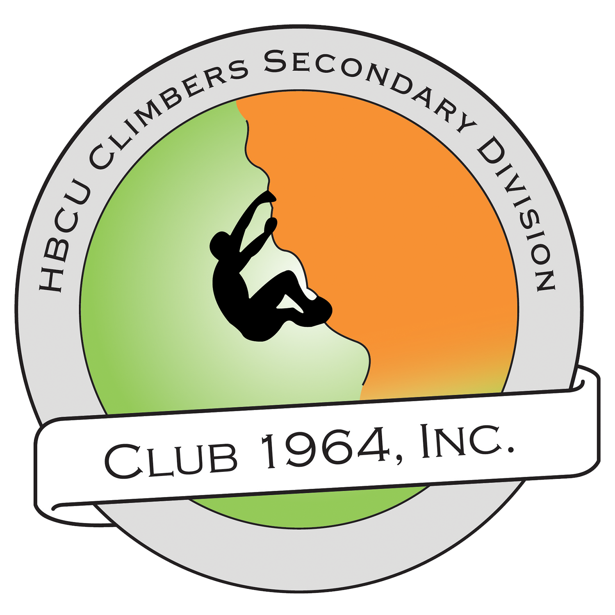

Club 1964, Inc.
HBCU Climbers Secondary Division
Program of Work: The [Insert School Name Here] Chapter

Point of Reference

Ventures/Initiatives
Programs, typically external/off-campus, to:
- Advance The Club 1964, Inc. GO-MVP.
- Promote Club 1964, Inc. Chapter or Campus.

Events/Activities
Programs, typically internal/on-campus, to:
- Advance The Club 1964, Inc. GO-MVP
- Promote Club 1964, Inc. Chapter
- Engage Membership.

Fundraisers/Campaigns
Efforts, external or internal, to raise funds for The Chapter and/or Organization.

Service
Efforts to benefit community or support a cause.

Outreach
Attendance at other events to:
- Support a Movement.
- Develop and Foster Relations.
- Promote Club 1964, Inc. Chapter or Campus.

Meetings
Scheduled meetings to be had by any Chapter Officers and/or Members.

Business/Administration
Background and foot work being done by Chapter Officers and/or Members.

Budget/Finances
Anticipated income, expenses, and balance.

Ideas

Ventures/Initiatives
- Pipeline Presentation, “What’s An HBCU?”, at local middle school.
- “Memphis-to-HBCU” Groupme/Facebook Page, to engage local students who want to go to an HBCU.

Events/Activities
- HBCU Panel - invite local HBCU students for panel discussion.
- HBCU Signing Day - A “signing day” for all graduating seniors enrolling into an HBCU.
- Rising HBCU Scholars Shoutout - A social media campaign where students who want to attend an HBCU are highlighted and the HBCU is tagged.

Fundraisers/Campaigns
- HBCU Climbers T-Shirt Drive - To raise funds for HBCU Tour.
- After School Snack Sale - To raise funds for trip Annual HBCU Symposium.

Service
- UNCF/TMCF Portal Community Sign-up - Invite community students to meet-up at library and help register in UNCF and TMCF portal for scholarships.
- Park Clean-up - Clean up local park.

Outreach
- Table at College Fairs - this’d be a great time to recruit other HBCU Climbers!
- Attend Local NAACP Meeting - this is a great place to meet HBCU Advocates!

Meetings
- Chapter Officer Meetings - every 3rd Thursday during lunch in Adviser’s class.
- Chapter Member Meeting - every 4th Monday after school in Adviser’s class.

*Identify what your chapter would like to do on, be sure to add dates next to your planned items. Also it’s completely okay if some months there’s no meetings, or service, our outreach, or anything because of testing, breaks, holidays, etc.
THE MONTH OF
AUGUST 2017

Ventures/Initiatives

Events/Activities

Fundraisers/Campaigns

Service

Outreach

Meetings

THE MONTH OF
SEPTEMBER 2017

Ventures/Initiatives

Events/Activities

Fundraisers/Campaigns

Service

Outreach

Meetings

THE MONTH OF
OCTOBER 2017

Ventures/Initiatives

Events/Activities

Fundraisers/Campaigns

Service

Outreach

Meetings

THE MONTH OF
NOVEMBER 2017

Ventures/Initiatives

Events/Activities

Fundraisers/Campaigns

Service

Outreach

Meetings

THE MONTH OF
DECEMBER 2017

Ventures/Initiatives

Events/Activities

Fundraisers/Campaigns

Service

Outreach

Meetings

THE MONTH OF
JANUARY 2018

Ventures/Initiatives

Events/Activities

Fundraisers/Campaigns

Service

Outreach

Meetings

THE MONTH OF
FEBRUARY 2018

Ventures/Initiatives

Events/Activities

Fundraisers/Campaigns

Service

Outreach

Meetings

THE MONTH OF
MARCH 2018

Ventures/Initiatives

Events/Activities

Fundraisers/Campaigns

Service

Outreach

Meetings

THE MONTH OF
APRIL 2018

Ventures/Initiatives

Events/Activities

Fundraisers/Campaigns

Service

Outreach

Meetings

THE MONTH OF
MAY 2018

Ventures/Initiatives

Events/Activities

Fundraisers/Campaigns

Service

Outreach

Meetings

